STATS 500 hw3

1. Fit a model with total sat score as the response and takers, ratio and salary as predictors.

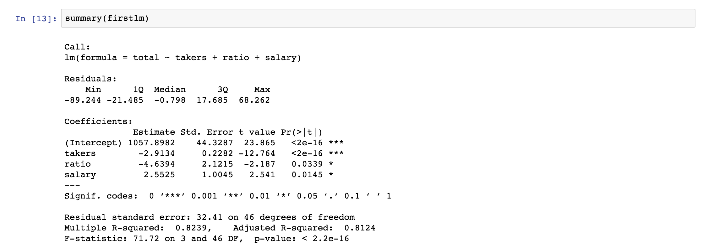

The takers and ratio are negative relation to the total sat score. And salary is positive effective. R-square is 0.8239, so the fitness of the model is good.

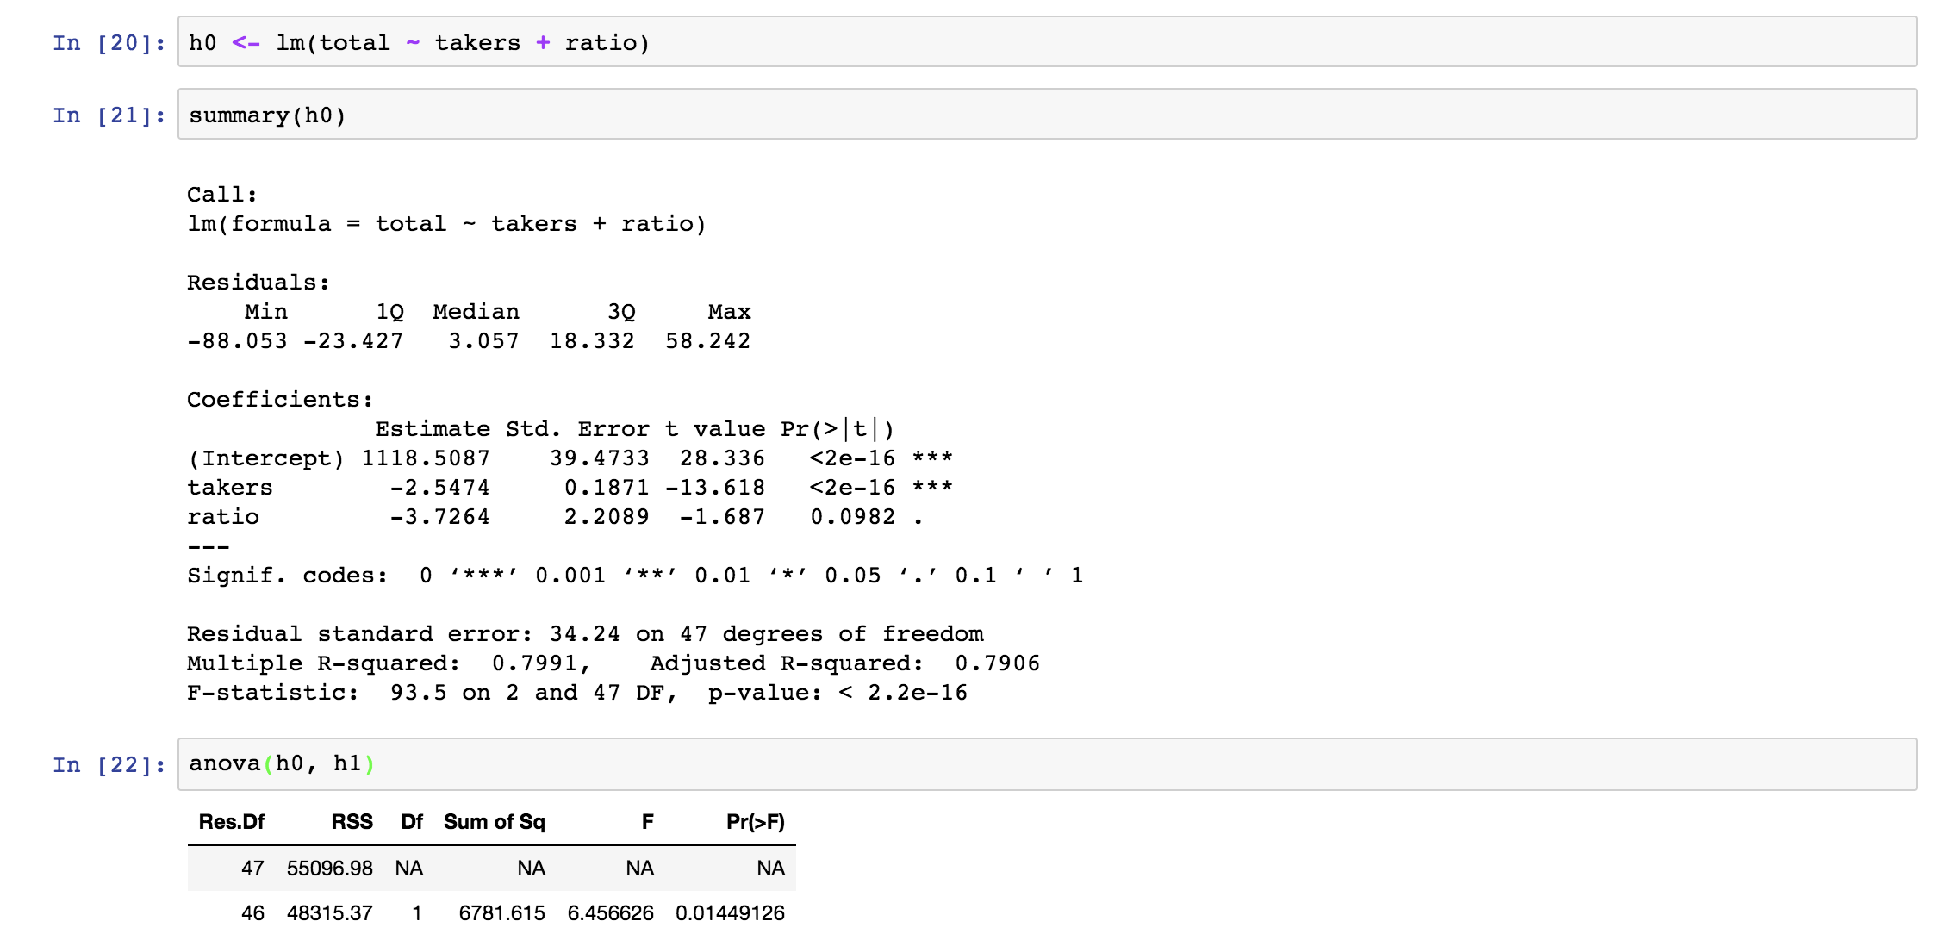

0.0145 < 0.05, reject H0. 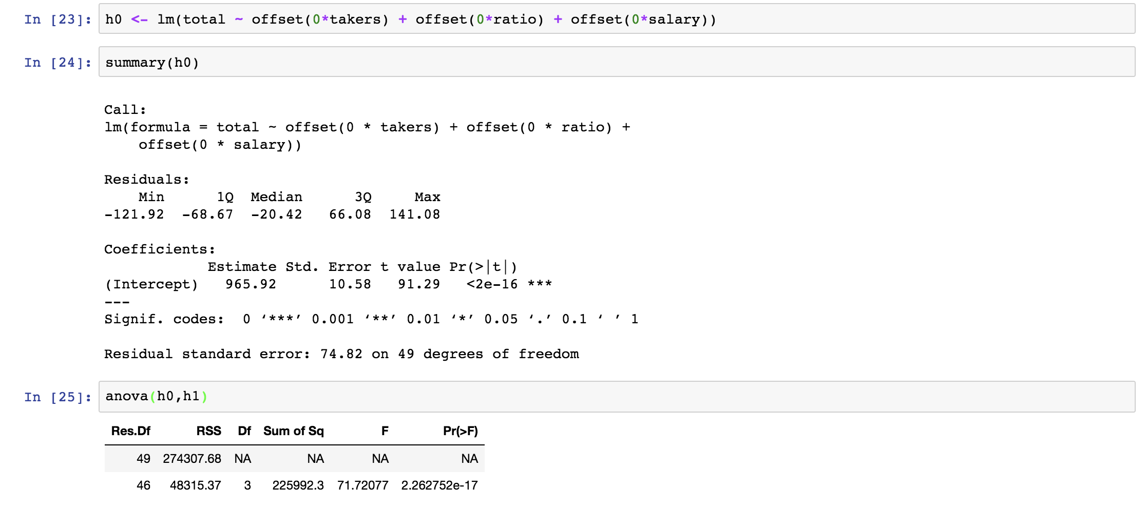

reject H0.

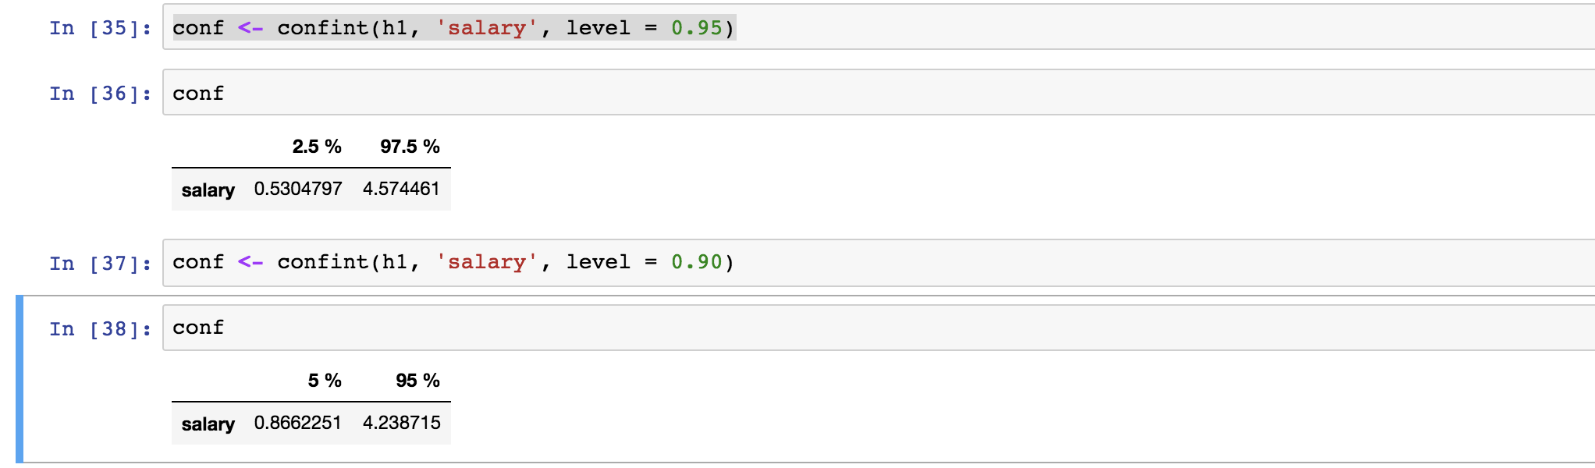

95% CI for beta(salary) does cover 0 🡪 fail to reject H0 at alpha = 0.5

90% CI for beta(salary) doesn’t cover 0 🡪 reject H0 at alpha = 0.1

p-value < 0.10 (p-value = 0.0145)

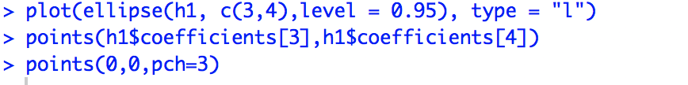

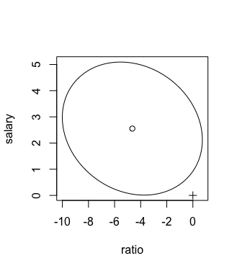

since the origin(0,0) is outside the ellipse, we Reject H0.

1. Add expend to the model

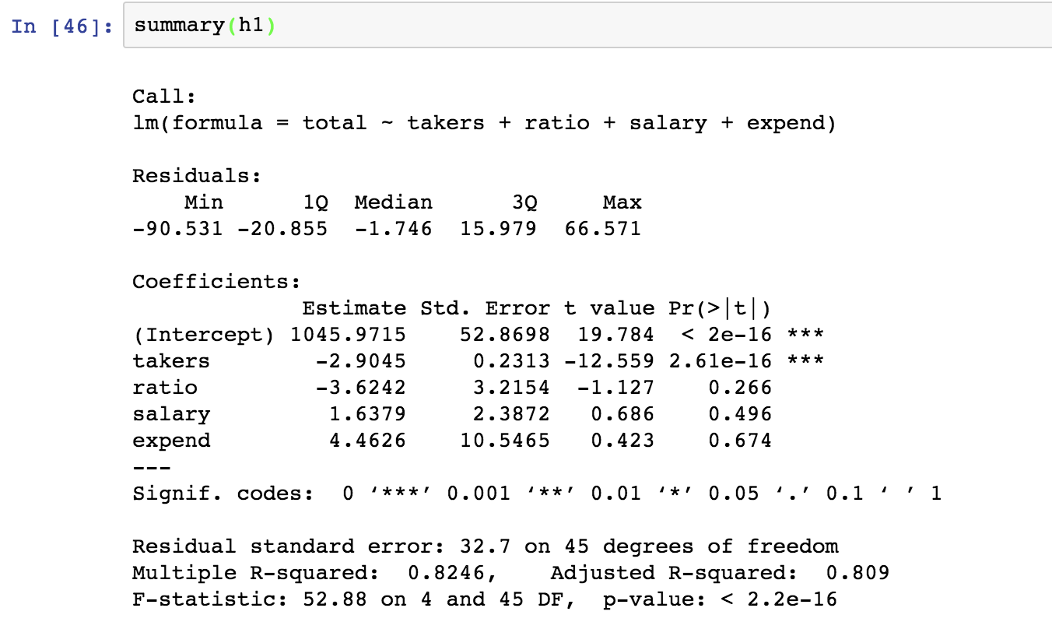

p-value of expend is higher than the other coefficients.

Compared to the first model, the R-square changed from 0.8239 to 0.8246. Also, the standard error are 32.7 and 32.41, which are close to each other, this two models are both significant.

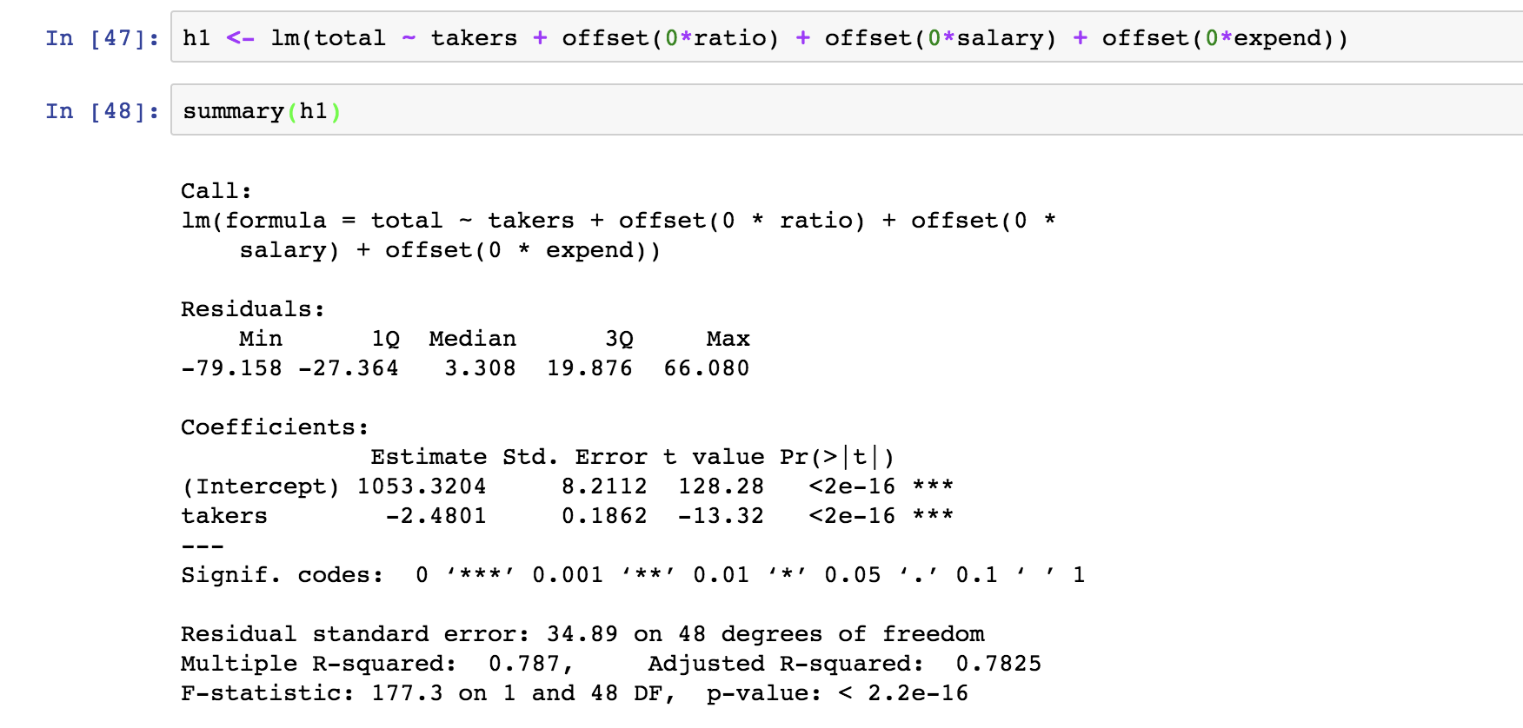

I think some of the predictors have an effect on the response.

1. A

